Advanced Artificial Intelligence
4. Transfer Learning
4.1 Introduction to transfer learning Basic terminologies, Pre-trained model and data sets, Feature extraction and fine tune transfer learning , Recent advancement in transfer learning : self-supervised learning and meta learning.
PAST QUESTIONS:
- What are the benefits of pre-trained models? (M24, M25)
- Explain transfer learning. Describe different types of transfer learning. (M24, M25)
- Explain self-supervised learning and meta learning with suitable examples. (D24)
- Explain the two transfer learning approaches. (D24)

NOTES:

*Transfer Learning :-
Transfer learning is an approach to machine learning where a model trained on one task is used as the starting point for a model on a new task. This is done by transferring the knowledge that the first model has learned about the features of the data to the second model.
Transfer Learning is a powerful machine learning technique where knowledge gained while solving one problem (source task) is applied to a different but related problem (target task). Instead of building a model from scratch, transfer learning leverages a pre-trained model—often trained on large-scale datasets—to accelerate training, reduce computational requirements, and improve performance, especially when labeled data for the new task is scarce.
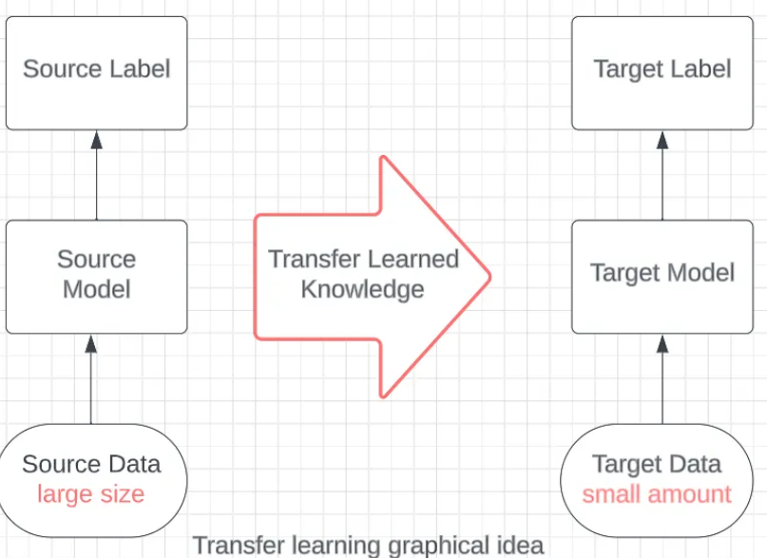
- To save time and resources: Training a deep learning model from scratch can be time-consuming and computationally expensive. Transfer learning can help you save time and resources by starting with a model that has already been trained on a large dataset.
- To improve model performance: Transfer learning can help you improve the performance of your model by transferring the knowledge that the pre-trained model has learned about the features of the data. This can be especially helpful if you have limited data for your target task.
- To solve problems with limited data: Transfer learning can be used to solve problems with limited data by transferring the knowledge that the pre-trained model has learned about the features of the data. This can be done by using feature extraction or fine-tuning.
- Adaptability: Models trained on one task can be fine-tuned for related tasks making transfer learning versatile for various applications from image recognition to natural language processing.

*Pre-trained model & Benefits :-
A pretrained model is a machine learning model that has been previously trained on a large dataset for a specific task (usually general-purpose) and can then be reused or fine-tuned for a different but related task. Pre-trained models save development teams time, data and computational resources compared to training a model from scratch.
Key Benefits of Pre-trained Models
- Accelerated Development: Instead of training from scratch, developers use existing architectures (e.g., ResNet, BERT), which significantly cuts development time and resources.
- Reduced Training Time: Building complex deep networks from scratch can take days or weeks; pre-trained models cut this to hours.
- Reduced Data Requirements: These models allow for high-performance results even with small, domain-specific datasets, as they already possess foundational knowledge.
- Improved Performance: Because they are trained on vast datasets, they often deliver higher accuracy, better generalization, and more robust performance than models trained on smaller datasets.
- Access to State-of-the-Art Results: Pre-trained models enable startups and smaller teams to leverage advanced architectures without massive, cost-prohibitive infrastructure.
- Transfer Learning Capability: They act as a foundational component, where lower layers are often "frozen" (feature extraction) while upper layers are fine-tuned for specialized applications.
- Cost Efficiency: Saves massive computational (CPU/GPU) power and human expert time required for expert knowledge labeling in tasks like NLP.
- Avoids "Re-inventing the Wheel": Proven architectures like Google's Inception (on ImageNet) provide a high-fidelity baseline that saves years of research effort.

* Feature Extraction & Fine-tuning :-
1. Feature Extraction - It uses the representations learned by the pre-trained network to extract meaningful features for new samples of a specific task. At this point, you can simply add a new classifier, which will be trained from scratch but on top the pre-trained model, so that you can reuse the feature map learned previously. Specifically, the pre-trained model’s parameters are kept frozen during training on the target task. This way you do not need to retrain the whole (more complex) model because the base network already contains features that are generally useful for different specific tasks.
Feature extraction is particularly useful when the target task has a small dataset or when computational resources are limited. Specifically, if the target task dataset is similar to the source task dataset you should perform a training on the pre-trained model features from higher layers (detailed features). Otherwise, if the dataset is very different from the original dataset, then you should perform a training on the features extracted from lower layers (general features).

2. Fine-tuning - In fine-tuning, the pre-trained model’s parameters are further trained (fine-tuned) on the target task’s dataset along with the additional layers. It consists in unfreezing some layers of a frozen pre-trained base model and jointly training both the newly added classifier layers and the last layers of the base model. This allows evolving not only the additional layers but also some of the earlier layers of the pre-trained model to better suit the target.
Fine-tuning is a machine learning technique in which a pre-trained model is further trained on a new dataset to improve its performance on a specific task. The pre-trained model is typically trained on a large dataset of general data, while the new dataset is specific to the task at hand.
It is typically used when the target task dataset is relatively large and similar to the pre-trained model dataset. On small datasets, it can be prone to overfitting, especially if the new task has significantly different features from the original pre-training task. Regularization methods (such as dropout and early stopping) can be used to tackle this problem. It typically requires higher computational resources and longer training time compared to feature extraction: since the entire model is trained, the backpropagation process needs to update a larger number of parameters.
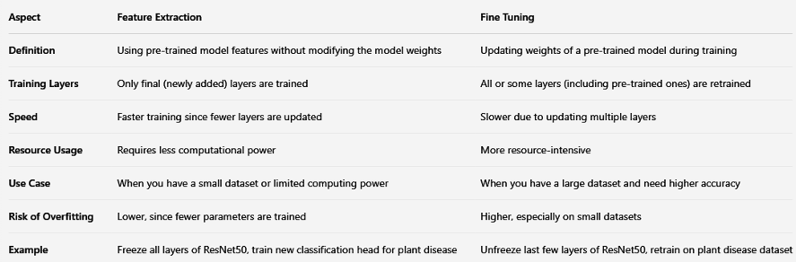
*Self-supervised learning :-
Self-Supervised Learning (SSL) is a type of machine learning where a model is trained using data that does not have any labels or answers provided. Instead of needing people to label the data, the model finds patterns and creates its own labels from the data automatically.
The model utilizes the inherent structure in the input data to generate supervision signals, such as predicting missing elements or reconstructing an input from a partially masked version. The goal of self-supervised learning is to learn representations useful for solving downstream tasks with minimal human labeling effort.
This allows the model to learn useful information by teaching itself from the data. SSL is especially useful when there is a lot of data but only a small part of it is labelled or labelling the data would take a lot of time and effort.
Two-Stage Process:
1. Pretraining: The model extracts features using a "pretext task" (e.g., predicting rotation or missing parts).
2. Fine-Tuning: The learned representation is used for a "downstream task" using a small amount of labeled data.

*Meta-Learning :-
Meta-learning is learning to learn algorithms, which aim to create AI systems that can adapt to new tasks and improve their performance over time, without the need for extensive retraining.
Meta-learning, also known as “learning to learn,” is a type of machine learning where the goal is to train models that can learn new tasks quickly and efficiently, based on their prior experience with other tasks. In other words, the models are trained to adapt to new tasks by learning from prior knowledge and experience. In meta-learning, a base model is trained on a set of related tasks and then fine-tuned on new, unseen tasks, using only a few examples. The idea is to allow the model to transfer its prior knowledge to the new task, thereby reducing the amount of data required to perform the new task.
Primary Phases:
1. Meta-Training: Exposure to multiple tasks to identify shared knowledge/patterns.
2. Meta-Testing (Adaptation): The model is given a brand-new task (few-shot learning) and must generalize quickly using very limited data.
Common Approaches:
o Metric-based: Learns a similarity function to compare images (e.g., nearest neighbor).
o Optimization-based: Learns an initial set of parameters that can be updated in 1–2 steps for new tasks.
o Model-Agnostic Meta-Learning (MAML): A popular optimization-based method with inner and outer loops.
o Model-based: Uses internal memory (Memory-augmented neural networks) to store and retrieve task information.

